Table of Contents:
- Background Info and Current State of Affairs
- Problem Statement
- Design Criteria
  - Realistic Cost-Revenue Ratio for Cooperatives/Drivers
  - Increased Safety
  - Increased Reliability - Service Times
  - Emission Reduction
  - Passenger Fares

Background Info and Current State of Affairs:

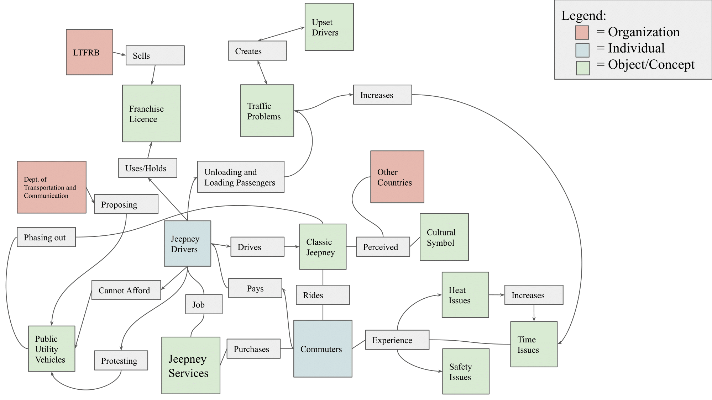
System Map of Social aspects of the Jeepney problem
In Manila, Philippines, there are a variety of public transportation options available for the millions of commuters within the region. A popular public transport system utilized are privately owned vehicles called Jeepneys. The current Jeepney vehicle fleet is getting quite old, most of the currently used Jeepneys in Manila are over 15 years old. The older engines in these vehicles are excessive producers of Greenhouse Gases (GHG), specifically producing 48% of particulate matter (PM2.5) in Manila [4]. Additionally, the current Jeepneys were not created with safety in mind, and the Jeepney sector itself is loosely organized and fragmented, resulting in big inefficiencies [6, 9].

The Philippines Government is looking to phase out the Jeepney vehicles by implementing a modernization plan (PUVMP) to combat the current fleet's existing economic, social, and environmental issues. This modernization program aims to modernize the Jeepney fleet, reduce emissions, and consolidate the currently independent drivers into cooperatives [7]. Though the modernization plan seems good on paper, a reduction goal was not set by the government when the plan was issued, and there is public criticism of the plan from stakeholders such as the drivers, small operators and cooperatives (Piston and Manibela). Concerns include a rushed deadline affecting livelihoods, loss of autonomy as drivers must surrender vehicles to cooperatives, and uncertainty about the environmental impact compared to cars. Additionally, the modern Jeepneys would cost between 1.3 million and 2.6 million PFP and have to be imported [8]. However, the government would only subsidize roughly 360,000 Pesos, leaving a substantial financial burden on Jeepney drivers and cooperatives [8].

Stakeholders:

Department of Transportation:
The Department of Transportation is the government branch with the most influence on the Jeepneys. The Department of Transportation was founded in 1979 to manage the formation and organization of transportation and other infrastructure for the country. Today they manage buses, trains, airplanes, and other public transportation systems [26].
They are important to this problem because this department is the one that has proposed the Public Utility Vehicle Modernization Program, which is the plan to replace old Jeepneys with more modern, less polluting vehicles [27]. As a stakeholder, they have a high influence on the problem but are less important than other stakeholders since they aren’t directly affected by Jeepneys.
The main goal of the Department is to create a public transportation system that is both cleaner environmentally, and safer for passengers [28]. Their other goal is to increase the quality of the system overall by making vehicles with more electronic components, larger capacities, and clearer schedules and stops.
Cooperatives:
Manila Jeepney cooperatives are associations or organizations composed of jeepney operators, administrators and drivers that aim to collectively manage and operate jeepneys.
The primary concerns of jeepney cooperatives revolve around modernizing, owning, and managing a fleet of 15 or more jeepneys along designated routes [3]. They would need enough capital and financial support for the modernization of their fleet in the form of subsidies, accessible loans with realistic repayment deadlines and interest rates [4]. To fund their expenses and repay their debt, they would need to charge fares from commuters and membership fees. Those expenses include social benefits and fixed salary for drivers [2]. Additionally, they would need training on fleet management, dispatching, and preventative maintenance to conform with regulatory guidelines.

Drivers:
The Jeepney Drivers are an important stakeholder in our problem landscape as they are directly interacting with the vehicles themselves. In relation to our sustainability goals, they would be particularly vulnerable to some environmental concerns, including existing climate change and air quality issues that prompted the government’s modernization plan [32]. Currently, the drivers themselves are actually protesting against the phasing out of jeepneys due to it primarily displacing more than half a million people, although it’s their main source of income and means of making a living [33]. The modernization plan that the government intends to carry out would place a sufficient financial burden on current drivers, sparking an interest in exploring the problem through an economic lens as well [11].

Passengers:

Jeepneys are the most popular form of public transportation in the Philippines [29]; therefore, the passengers are a large group of people. As they use Jeepneys as their transportation, they are reliant on these vehicles for getting to their jobs and, by extension, maintaining their livelihoods. They are low-influence, however, because, in the end, they are dependent on the system while the government and Jeepney owners run it. Their interest is having reliable and safe transportation. Using Jeepneys as transportation, it is essential that they serve their purpose of moving passengers between places on time. If passengers do not get to their destination on time, they have not had their needs met.

Passenger Fares
The financial implications of any solution aimed at modernizing Jeepneys in Manila are significant, and there are valid concerns about the potential impact on fare prices for commuters. Many passengers, especially those with lower incomes, rely on Jeepneys as a primary mode of transportation due to their affordability [14]. Therefore, ensuring that any changes do not result in fare increases that could disproportionately affect these users is essential. Last October, Jeepney fares were already increased by 1PHP, bringing the fare for a traditional Jeepney to 13PHP and 15PHP for a modern Jeepney [12]. Further fare hikes could place a strain on commuters, particularly those who rely on Jeepneys as their primary means of transportation. The jeepney fares should be no more than 6% of the minimum wage in Metro Manila to keep up with historical trends. The minimum wage is 573PHP since July 16, 2023 (34 PHP fare cap) [16, 17]. Achieving this goal would require careful consideration of the costs and benefits of any modernization efforts and implementing measures to support operators and commuters alike.
Realistic Cost-Revenue Ratio for Cooperatives/Drivers
Many Jeepney operators in Manila are grappling with the challenge of modernizing their fleets due to concerns about the high cost involved. Upgrading to newer, more environmentally friendly Jeepneys requires a significant financial investment that many operators find difficult to afford [23]. The amount of money Jeepneys make is less than the debt payments they would be required to make [23]. Modern Jeepneys cost between 1.3 million to 2.6 million PHP [8]. The government would subsidize only 360 000 PHP (28% of the cheapest modern vehicle) [8]. Drivers estimate they would need to earn at least 6000 PHP daily to repay loans [11]. Cooperatives and drivers would incur significant debt for each jeepney bought (Annex C). According to our estimates, 11 billion would be needed to support the modernization of unconsolidated jeepneys (not including other ancillary costs promised by the government) (Annex B). The design should allow cooperatives, drivers and operators to maintain a cost-revenue ratio as close to one as possible. This means that the fares, government subsidies and other entrepreneurial initiatives should cover the monthly loan payments required for modernization and operational and maintenance costs [15].
Increased Safety

In 2019, there were 10,296 jeepney crashes in Metro Manila, 40 of which resulted in deaths and 1,817 caused non-fatal injuries. One of the main goals of the modernization effort was to make jeepneys safer on the roads and safer for passengers. For our design, we would aim for deaths and injuries from road traffic accidents per 100,000 population should halve as per the Philippines’s SDG target 3.6 [18]. Make all forms of harassment and violence on jeepneys reportable.

Increased Reliability
In 2023, Metro Manila had the worst travel time of any metro area globally [13]. A significant factor contributing to this congestion is the frequent and unplanned stops made by Jeepneys along their routes [21]. We aim to lower the average travel time for Jeepneys. This reduction is crucial for improving the efficiency of Metro Manila's transportation network. In general, a jeepney typically travels an average distance of 7 kilometres.; the speed of a jeepney varies depending on the level of traffic congestion, but on average, a jeepney trip takes around 26.7 minutes [19]. However, as the distance increases, the travel time also increases. For example, doubling the distance can result in a travel time of up to 90 minutes [19]. A stakeholder mentioned that a trip normally taking an hour on a motorcycle could take up to 3 hours on a jeepney [20]. The objective is to maintain a consistent average travel time per kilometre, regardless of the distance travelled while ensuring the speed does not fall below 15 km/h [19].

Emission Reduction

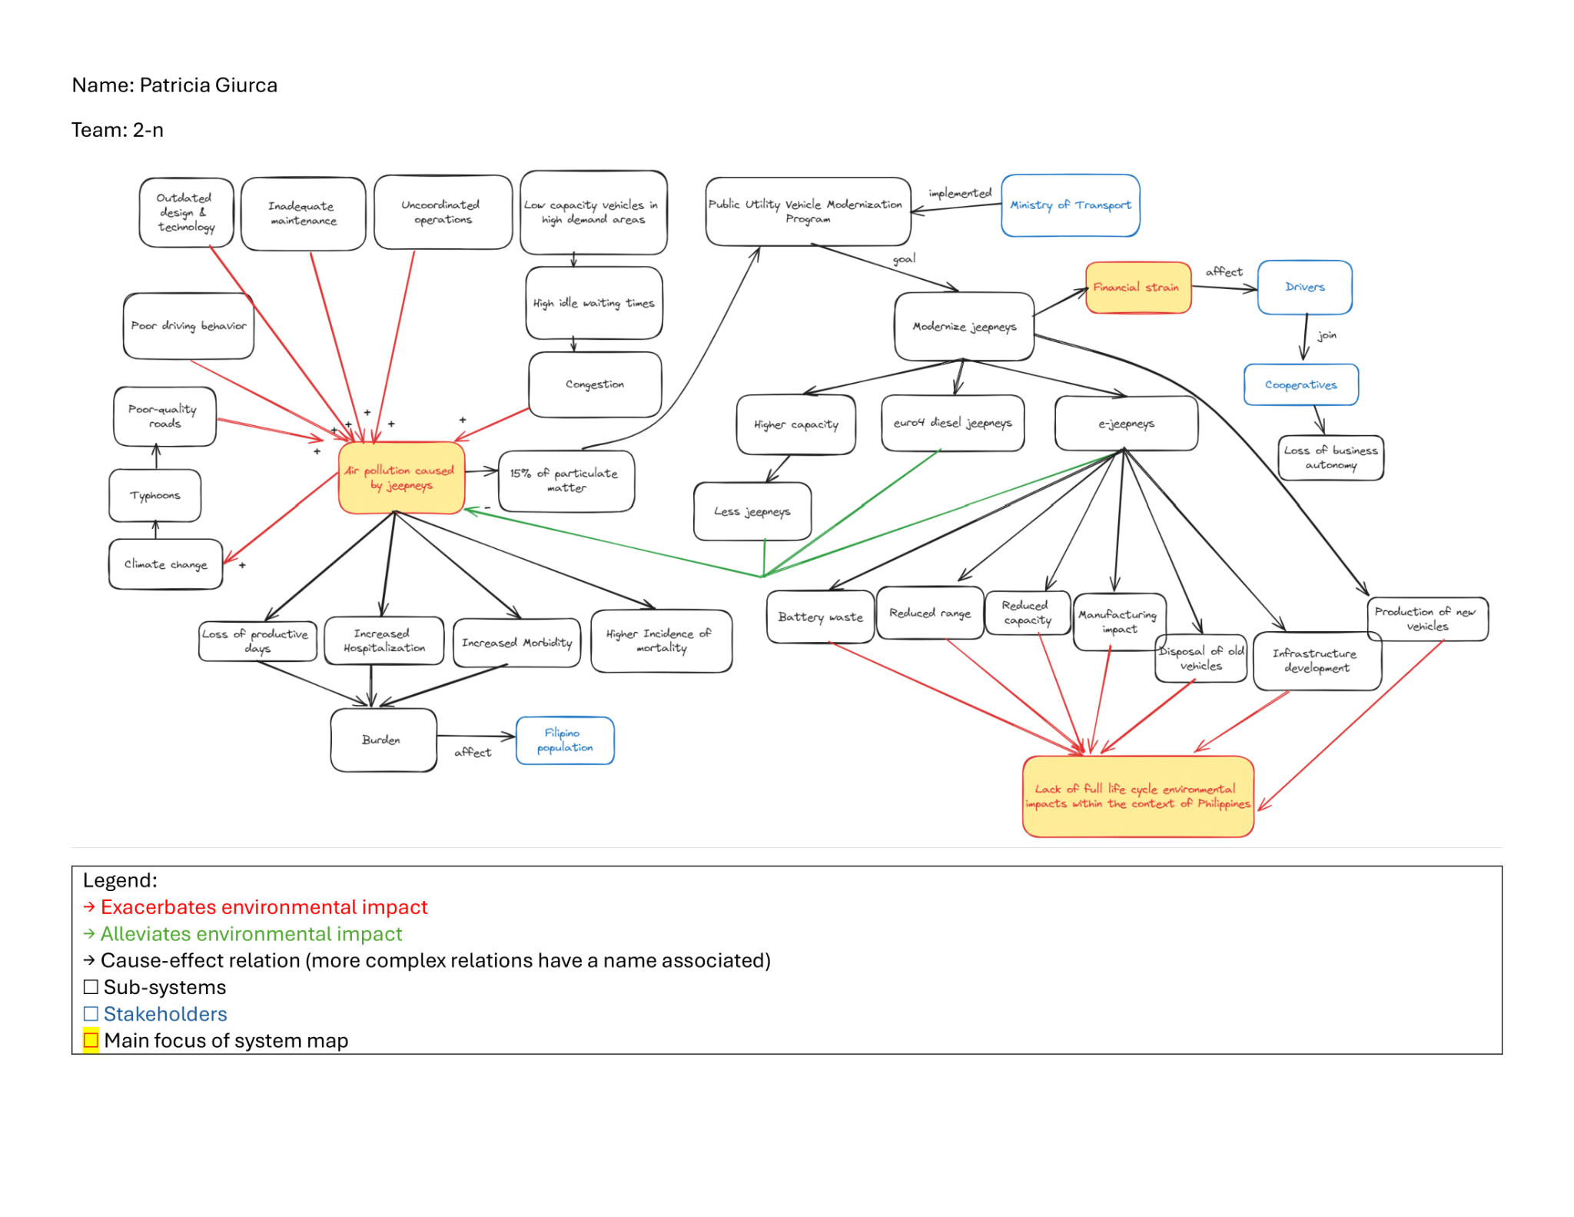
System Map of Environmental aspects of the Jeepney Problem

In addressing the environmental design criteria, we want to better understand the current effects of Manila’s Jeepney public transportation system on the environment. Our goal is to reduce the emissions and pollution levels that would come from the Jeepneys themselves, which entails determining methodologies of measuring this data and also researching other instances of transportation companies undergoing sustainability upgrades to their systems.

To address Manila’s environmental issues through public transportation, we decided to look into other countries with similar GDP, and how they reduce emissions in public transportation services. Singapore has a similar GDP, and a public transportation service called the Singapore Mass Rapid Transit (SMRT). According to the IMF, [24], The GDP of Singapore is $497.3 million USD and the GDP of the Philippines is $435.6 million USD based on 2023 collected data. The SMRT has set a goal of reducing greenhouse gas emissions by 50% over the course of twenty years [20], which we believe is a goal applicable to Jeepneys.

We’re looking to address the extensive emissions being produced by the current Jeepney vehicles and the health effects on the passengers and drivers. Like any other motor vehicle, these Jeepneys pollute the surrounding Manila environment by emitting carbon dioxide, specifically a particulate matter called PM2.5 [22]. Drivers are being exposed to this pollutant during peak hours, such as the morning and afternoon rush hour. There is a correlation between heavy traffic and observed PM2.5 levels, so this is the pollutant we want any solution to focus on.

In Figure 2, a map of a frequently used Jeepney route can be found. It’s color coded by the driver exposure to PM2.5 levels [22]. A key area of interest on this map is the Mall, where it can be determined that heavy traffic congestion is present in this particular area. This keys in on the fact that vehicular traffic is contributing to this heavy exposure of PM2.5 levels to the drivers.
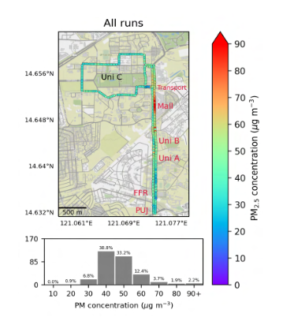

In Figure 3 [22], we can see a normal distribution of PM2.5 concentration frequencies recorded across Manila. However, the concerning aspect of this figure is that the 30-day average PM2.5 concentration in Manila far exceeds the World Health Organization’s mean annual threshold of 5 µg/m^3 [25]. This excessive concentration of particulate matter presents adequate means of pursuing this problem and taking action.
